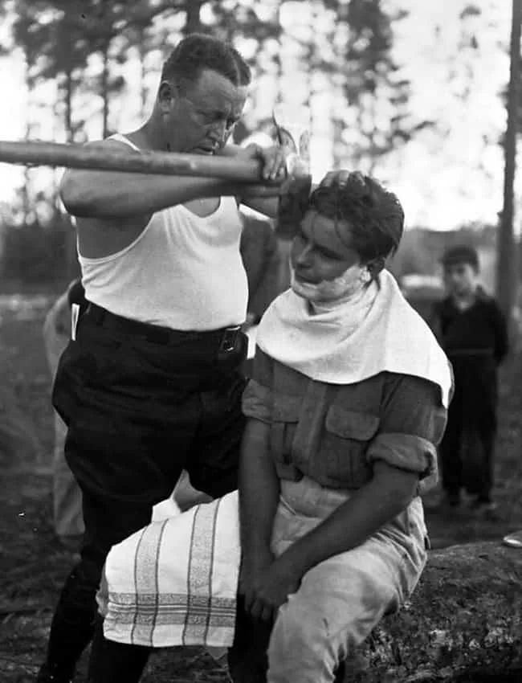

I think that the Photographer is trying to show that point of view that some times you had to use what you had around that you may not have the privilege of what now is a common thing to have like a razor. It is also representing helping people other than yourself, I also think that the photo strongly shows trust, because if you didn’t trust some one with your life why would you let then scrape the hair off of your face with an ax.

